Name:______________________________________________________

Employee/Vendor Id #: ________________ (CHECK) Employee Vendor

Contact Information
Name: ____________________________________________
Tax ID No: ____________________________________________
Address: ____________________________________________
City, State & Zip: ____________________________________________
Email: ____________________________________________
Telephone: ____________________________________________
Bank Information
Routing/Transit Number: (9 digits)
Bank Name:
Account Number:
Account Type: Checking Savings
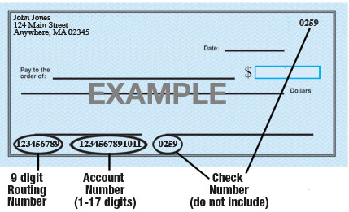
Authorization
I hereby authorize The College of New Jersey to deposit funds directly into the account designated. I understand that all subsequent payments to me will be via direct deposit. I agree that The College of New Jersey will not be responsible for any incorrect information I provide.
__________________________________________ ____________________________
Signature Date

